Job Ready Master – Microsoft SQL Server

# Lesson 1 Learn Objectives:

* Understand the principles of Relational Databases and SQL (Structured Query Language).
* Use Transact – SQL statements to structure and customise.
* Databases (in MS SQL servers) as well as for storing, retrieving, and manipulating data in relational databases.
* Using SQL in data analysis (BI and reporting tools)

## Why should learn SQL

* Is a data collector?
* Used by Data Analyst, Data Scientists, Data Engineer, Data architecture and others.

## Some important terms

Database management system, Relational Database management system is a type of database management system that stores data in a row-based table structure which connects related data elements. An RDBMS includes functions that maintain the security, accuracy, integrity, and consistency of the data.

### Schema

Schema is a new term used by SQL Server since the first time in 2005, to collect tables that share the same traits which makes it easier to manage.

If not using schema in Data management, its default becomes dbo. The dbo schema is the default schema of every database. By default, users created with the CREATE USER transact – SQL command have dbo as their default schema. Dbo stands for database owner.

## SQL Introduction:

SQL: stands for Structured Query Language, which is a structured query language, allows you to access and manipulate databases. SQL is standard language for relational database system, All database management systems (RDBMS): MySQL, MS Access, Oracle, Sybase, Informix, Postgres or SQL Server adopt SQL as the standard database language.

**SQL Benefits:**

* Build a database instead of storing many excel and csv files in many folders.
* Unlimited number of lines like excel.
* Use, call data quickly, do no have to open excel file. High speed and take advantage of the maximum hardware power.
* Analyse data (basic level) at high speed
* Relative push functions as above excel.

## SQL Interface

After SQL Server 2022 and SSMS have been loaded. The SSMS access will have a login interface based on the computer name.

Step 1: click connect

Step 2: click the new query to create a new SQL query.

Step 3: This allows writing SQL statements to process data. The master section at the top near the menu bar shows where we select the database, and the default data base when opening SQL is the master.

### Working interface overview:

1. The menu bar contains common tasks used to open SQL files, save SQL files, SQL server administrative operations.
2. Execute button, stop buttons to manipulate SQL statements

The left part is **SQL browser,** which contains a tree of components in SQL Server from the SQL Server -> Database level -> Table -> Columns / Rows.

1. The upper right screen is where we write thousands of SQL statements to calculate and synthesize data.
2. After running SQL statement, the result of statement will display on the lower right screen. The result of the statement can be data after calculation.
3. The statement that runs successfully will have a blue message ‘’Query executed successfully”, other wise there will be an error message.
4. Computer name and SQL Server name
5. SQL statement execution time.
6. The resulting line number of the SQL select statement.

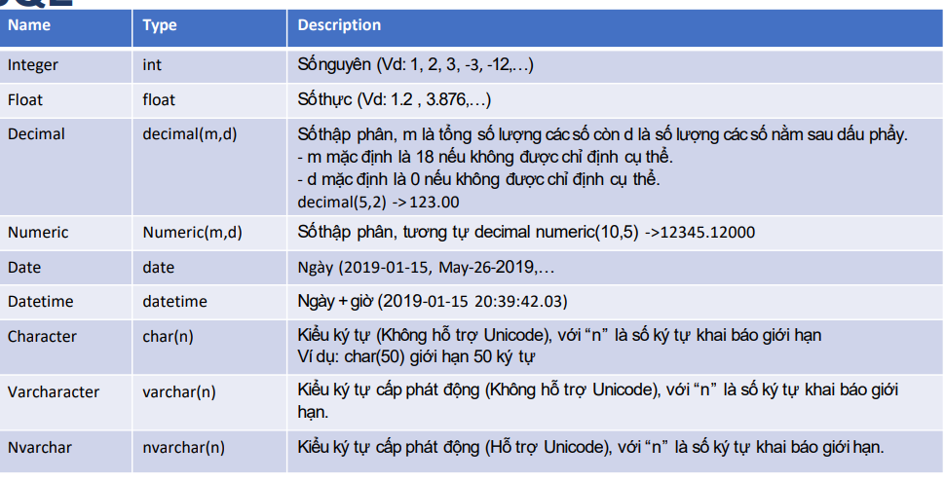

### SQL data grammar:

1. SQL is not case sensitive
2. SQL starts with any statements like DELETE, ALTER, DROP, … and ends with ;
3. REMINDER: remember to clearly state the address and name of table to avoid errors and misuse tables when typing SQL statements. E.g.
   1. MCI is database name – dbo is the tail name – Transact2 is the name of the table
   2. The default structure is Database.dbo.table_name

## Some useful tools:

### Main type of SQL commands:

DQL: Data Query Language

DDL: Data Definition Language

DCL: Data control Language

DML: Data manipulation Language

TCL: Transaction Control Language.

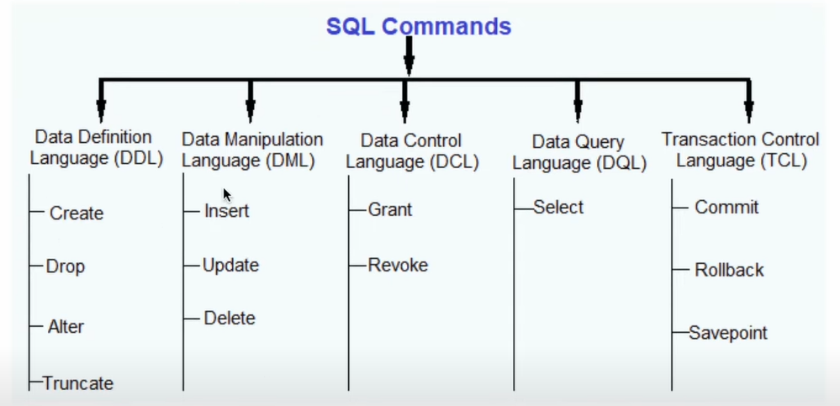

Lesson 2 – SQL Basic Query Statements

# Lesson 2 – SQL Basic Query Statements

## Basic Query Statements

## SELECT STATEMENT

### SELECT TOP N:

## WHERE STATEMENT

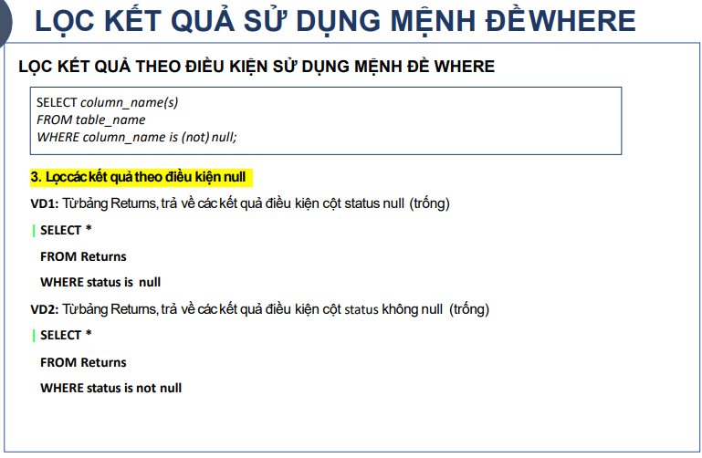

## MAX() and MIN()

## COUNT, AVG and SUM

## GROUP BY

Purpose of Group by

Group by uses strategy as extract, apply and combine where:

* Extract: divided into groups based on their values
* Apply: Use Statements on values of these groups
* Combine: All values are combined

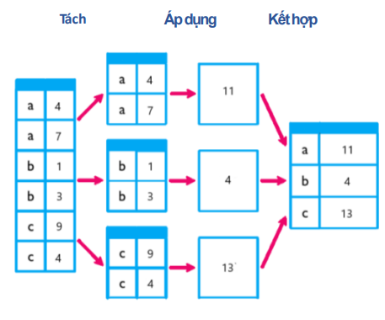

## Order by:

## Having:

## Summary

Lesson 3 – JOINS in SQL

# Lesson 3 – JOINS in SQL

## JOIN and UNION:

JOIN: we use the join clause, to combine the attributes of two given relations and as a result form tuple. Joins columns

UNION: we use the UNION clause when we want to combine the results obtained from two queries. Join rows.

## Introduction to JOIN in SQL: INNER, LEFT, RIGHT, FULL

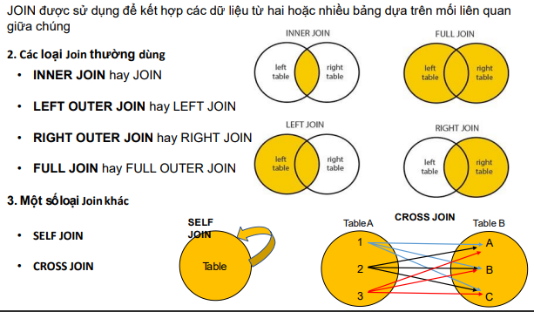

## SELF JOIN and CROSS JOIN:

## UNION and UNION ALL:

Union ALL will take everything from both tables, while UNION will take both table but those shares similar values will be included but not duplicated.

Lesson 4 – Data Processing Functions

# Lesson 4 – Data Processing Functions:

## Data processing functions – sequencing

## Data processing functions – times sequencing

## Data processing functions – Conversion functions

## CASE WHEN statement:

Lesson 5 – View, CTE and Subquery in SQL

# Lesson 5 – View, CTE and Subquery in SQL

## What is Subquery in SQL:

A subquery is a query that appears inside another query statement. Subqueries are also referred to as sub – SELECT s or nested SELECTs. The full SELECT syntax is valid in subqueries. This subquery lies after statements WHERE, FROM or SELECT.

Note: Subquery is also called INNER QUERY or INNER SELECT. Main query is called OUTER QUERY or OUTER SELECT

## Rules with Subquery

1. Subquery must be called in a bracket
2. Cannot use order by insider subquery, even though the main query can use ORDER BY.
3. GROUP BY can be used normally inside subquery.

## **CTE in SQL Server (MOST IMPORTANT TOPIC):**

CTE is a common table expression (CTE) is a named result set in a SQL query. CTEs helps keep your code organised and allow you to perform multi-level aggregations on your data, like finding the average of a set of counts.

* CTE makes code readable.
* CTE can reference the results multiple times throughout the query.
* CTEs help you perform multi-level aggregations

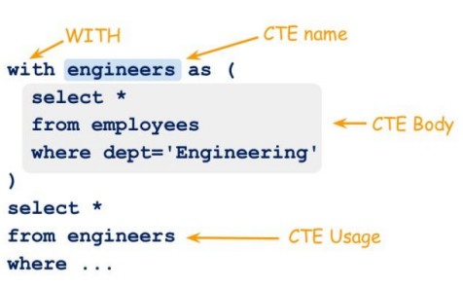

## Ways to use CTE – Common table Expression

**Purpose of CTEs**

* To create recursive query
* To replace VIEW in some scenarios
* We can use CTE many times in a query.

**Advantages of CTEs.**

CTEs has multiple benefits like the ability to read data to simplify and unwrangle complex query. Making queries to form into multiple smaller, simpler queries. These blocks of queries are used to construct higher levels of CTEs query until the final expression is formed and satisfied.

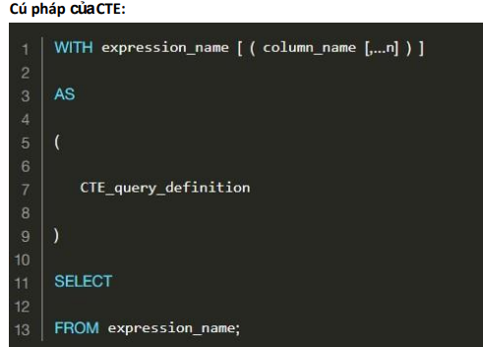

## What is TEMP TABLE and How to use TEMP TABLE:

**What is a TEMP TABLE:**

A temporary table is a base table that is not stored in the database, but instead exists only while the database session in which it was created is active. In SQL Server, temporary table is created and stored in tempdb. There are 2 types of TEMP TABLEs:

1. Local Temporary Table: Is used to create TEMP TABLE and only exists in the user using the table and will be destroyed when disconnected. Local Temporary table is created using a CREATE TABLE statement with the table name prefixed with a single number sign (#table_name)
2. Global Temporary Table: Is used to create TEMP TABLE and only exists until all connections to data centre are closed. It can be used from other people’s connections to the data.

**Advantages:**

Many benefits of using Temporary Table instead of working with fixed table

* When you want to have full access to all tables in Database, but you don’t have. You could use your access to read to drag data into your TEMP TABLE of SQL Server and perform modifications on it.
* Or you don’t have the access to create table in the database, you could create a TEMP TABLE and perform SQL queries on it.
* Finally, in scenario where you only need to view the data in the current, and to update insert data before viewing.

Lesson 6 – Pivot Tables and Ranking in SQL

# Lesson 6 – Pivot Tables and Ranking in SQL Server

## Structure of a PIVOT Table

## Ranking TOPIC

We use ROW_NUMBER(), RANK() and DENSE_RANK()

### ROW_NUMBER()

### DENSE_RANK()

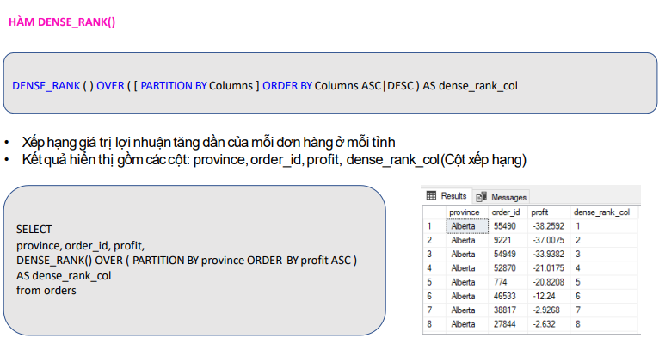

### RANK():

## Summary:

# Lesson 7 – INSERT, UPDATE, DELETE Table in SQL Server.

## INSERT INTO

There are two ways:



This is for every column of the tables.

## DELETE()

### Drop table

We learnt this in class

### DELETE()

## UPDATE():

There are 2 ways to use UPDATE

# TIPs THAT I used:

## Removing dash redlines when reloading

Ctrl + Shift + R: hard reload cache to remove red lines after importing excel files or other files into the database.

## Changing Specific column-RowName when union

To change row names, we include the ‘ ‘ for the column name and put the string name into it. WARNING this is for UNION ALL

